EECE5001 Senior Design 1 Autumn, 2020
Class List [section 001]
Surname | First Name | ID | Signature
Adams | Brad Taylor | M10459827 |  | 1
Adkins | Tyler | M10261183 |  | 2
Armitage | Evie Frances | M10179876 |  | 3
Arvin | Korey Daniel | M12972392 |  | 4
Barve | Siddharth | M12605496 |  | 5
Becker | Beau Bryson | M10120807 |  | 6
Blickley | Eric Michael | M10313596 |  | 7
Brode | Davis | M10286137 |  | 8
Campbell | Steven | M10442056 |  | 9
Castenir | Joe Matthew | M10194662 |  | 10
Chase | Cole J | M10296220 |  | 11
Cold | Erin Cynthia | M10115354 |  | 12
Dinsmore | Nick | M10285249 |  | 13
Foreman | Grant Hays | M09006206 |  | 14
Frey | Michael G | M10278807 |  | 15
Frierson | Tony | M10180332 |  | 16
Fuenfgeld | Tori Nicole | M10185344 |  | 17
Grimes | Benjamin | M06224064 |  | 18
Haxton | Kevin | M10192915 | 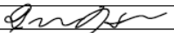 | 19
Henggeler | Robert | M10278313 |  | 20
Henry | Moriah L | M10188772 |  | 21
Hernandez | Nathaniel Rogelio | M11002693 |  | 22
Horsman | Jim Curtis | M10192712 |  | 23
Hummel | Colt | M10204525 |  | 24
Jester | Colin Chaney | M10118782 |  | 25
Jones | Abby | M10302707 |  | 26
Kaiser | Grant James | M10191357 |  | 27
King | Vincent | M10289311 |  | 28
Labarowski | Branden | M08980912 |  | 29
Liu | Zuguang | M10291593 |  | 30
Luo | Kevin | M10338283 |  | 31
Matwiejczyk | Grant Edward | M10123303 |  | 32
May | Josh M | M10459106 |  | 33
McDaniel | Evan | M10252957 |  | 34
Melvin | Gerik | M10168034 |  | 35
Menczywor | Joshua | M10206336 |  | 36
Mraz | Daniel | M10121375 | 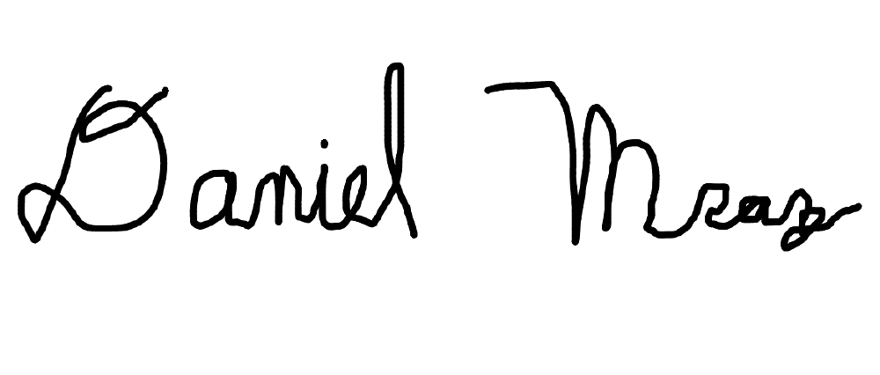 | 37
Mulcahy | Liam | M10340690 | 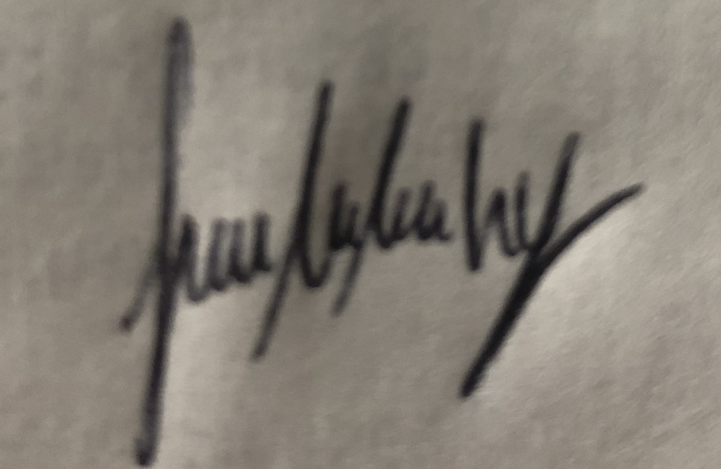 | 38
Murali | Aravind | M10248659 |  | 39
Murphy | Joseph Ambrogino | M10276633 | Joseph A Murphy | 40
Murphy | Joseph Paul | M10610240 | 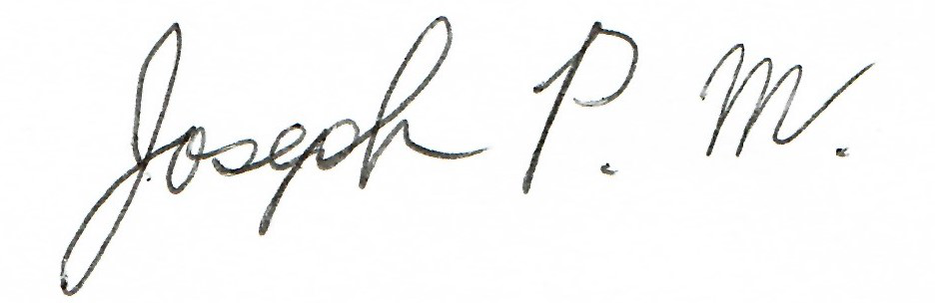 | 41
Musser | Chris Glenn | M10312550 |  | 42
Nguyen | Quan | M11136827 |  | 43
Patel | Meet Sharadchandra | M08318988 |  | 44
Peluso | Parker Jarrett | M10207160 | Parker Peluso | 45
Plaver | Adam John | M10302336 |  | 46
Pottschmidt | Kiefer John | M10263576 |  | 47
Pownell | Chase Michael | M10603999 | 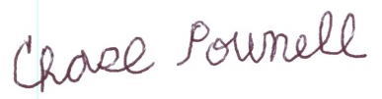 | 48
Raczak | Jeromy Joseph | M10172586 |  | 49
Ranly | Peter Roland | M10327509 | 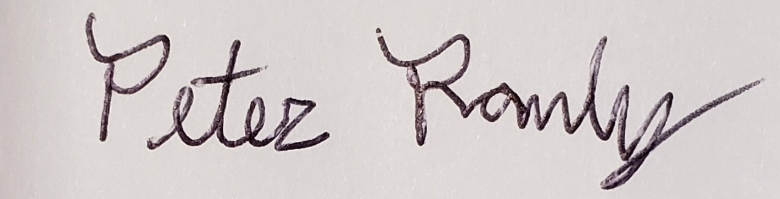 | 50
Richards | Justin | M10264296 |  | 51
Rickert | Jonny Joseph | M08899700 |  | 52
Rockas | Dominic Martin Daniel | M10285871 |  | 53
Rook | Billy Thomas | M10178953 | 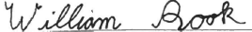 | 54
Ruehl | John R | M07346864 |  | 55
Ruen | Aaron | M10115346 |  | 56
Sasse | Tyler William | M10260893 |  | 57
Schoning | Jack | M10196326 |  | 58
Sharma | Kartik | M13579955 |  | 59
Smiddy | James | M10403938 |  | 60
Smith | Preston T | M10161019 |  | 61
Spaeth | Alec Joseph | M10302598 |  | 62
Stack | Sloane Elliott | M10280579 | Sloane Stack | 63
Taylor | Danny | M10197070 |  | 64
Tenaglia | Conner | M10119275 |  | 65
Trester | Alan Theodor | M10400526 |  | 66
Twiddy | Scottie | M10164308 |  | 67
Underwood | Zachary Adam | M06671032 |  | 68
Vober | James | M10276721 |  | 69
Wang | Zhaonian | M10877383 |  | 70
Watren | Jacob | M10589111 |  | 71
Williams | Eric J | M04347263 |  | 72
Willwerth | Jared William | M08032605 |  | 73
Woodruff | Chase Michael | M10119080 |  | 74
Yelmgren | Eric Robert | M10554883 |  | 75
Zelaski | Levi | M10321676 |  | 76
Zhao | Mingyuan | M10652029 |  | 77

